Lab for Unit 3
Question 1: Arrange the following statements in order to describe the working of a neural network.
- The bias is added.
- The weighted sum of the inputs is calculated.
- Specific Neuron is activated.
- The result is fed to an activation function.
Select the correct order.
- DABC 2. BADC
Question 2: What is the correct architecture of convolutional neural network?
- Input image Convolutions Pooling Fully Connected
- Input image Pooling Convolutions Fully Connected
Question 3: What is the function of gradient descent in neural network?
1. Find the minimum of a function of multiple variables.
2. Find the maximum of a function of multiple variables.
Question 4: Backpropagation is the method of fine-tuning the weights of a neural network based on the error rate obtained in the previous epoch (i.e., iteration).
- False 2. True

Question 5: What is the name of the following activation function?
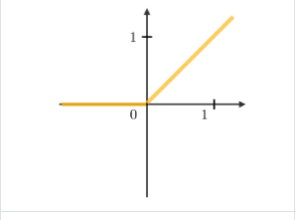
- Sigmoid 2. ReLU

Homework : Check the videos and references and suggest the task that can be solve using CNN

References:
- Deep Learning In 5 Minutes | What Is Deep Learning? | Deep Learning Explained Simply | Simplilearn – YouTube
- CS 230 - Convolutional Neural Networks Cheatsheet (stanford.edu)
- http://education.sdsc.edu/training/201910_intro_to_deep_learning/recording/
- But what is a Neural Network? | Deep learning, chapter 1 - YouTube
- Gradient descent, how neural networks learn | Deep learning, chapter 2 - YouTube
- What is backpropagation really doing? | Deep learning, chapter 3 - YouTube
- Backpropagation calculus | Deep learning, chapter 4 - YouTube

